Cpp Convention

# 0

On top of the main source code , the Author and Statement of Purpose must be addressed

# 1

If a built-in library is included in the source code, always insert the line

Never use breakpoint to observe the output. Instead, use

definition

image

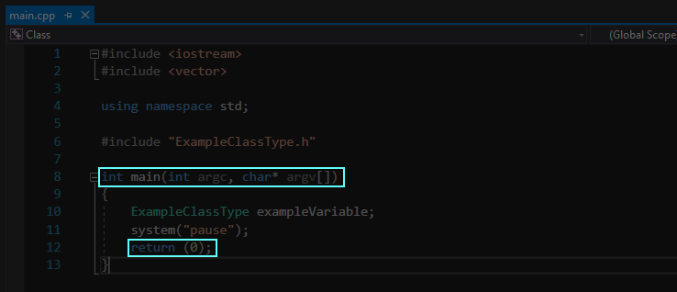

image end

# 2

Iterator declaration

image

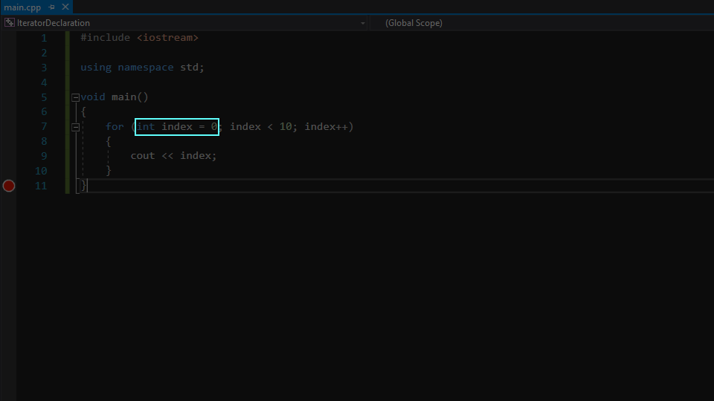

image end

# 3

Class

Document

# 4

Function

Parameter must always be declared as a call-by-reference parameter

If parameter is read only, it must be declared as a constant call-by-reference parameter

# 5

Iterating elements of containers

image

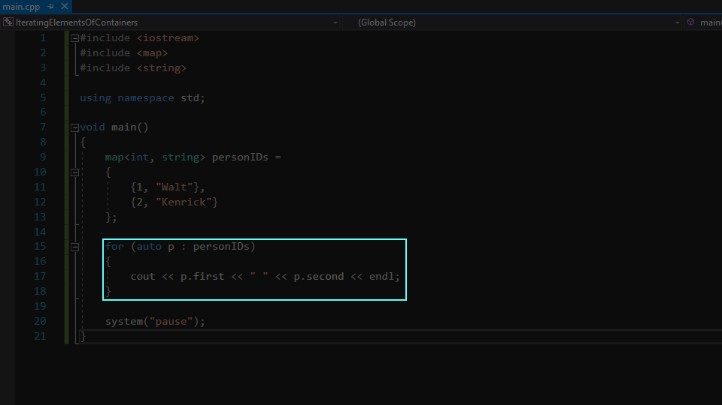

image end

# 6

Constant

Constant name must be of capitalized alphabets

If constant name is not unary, the words must be connected by the underscore symbol

# 7

CODE REVIEW

Code must include adequate comments

Code must be formatted with Astyle <https://1drv.ms/b/s!ApS5O7jNq4bk81UPsivtfcI9Ke2Z>

# 8

When the instruction is followed up by , always insert in between

# 9

Pointer

Always use to represent the null pointer

Pointer that points to an array-like data structure and that is a class’s member variable must be an ordinary pointer, and should only work with dynamic data type

# 10

Array

Always use vector. Never use array

Further information regarding array <https://stackoverflow.com/questions/4810664/how-do-i-use-arrays-in-c>